***RMMM PLAN FOR HOSPITAL MANAGEMENT SYSTEM***

***Risk Information Sheet:*** *Hospital Management System Software Application*

***Risk:*** *Data breaches and privacy violations*

***Description:*** *The software application contains sensitive patient and staff information. If this information is accessed or stolen by unauthorized parties, it could lead to legal and reputational damage.*

***Impact:*** *Financial losses, legal action, loss of trust and reputation*

***Likelihood:*** *Moderate*

***Mitigation strategy:*** *Implement strong encryption and access controls, conduct regular security audits and assessments, and provide staff training on data security best practices.*

***Risk:*** *System failure or downtime*

***Description:*** *The software application is critical to the operation of the hospital. If the system experiences downtime or failure, it could disrupt patient care and cause delays.*

***Impact****: Delayed patient care, loss of revenue, damage to reputation*

***Likelihood****: Low to moderate*

***Mitigation strategy:*** *Implement a robust backup and disaster recovery plan, conduct regular system maintenance and updates, and ensure that there are redundancies in place to prevent single points of failure.*

***Risk:*** *Inadequate user training or support*

***Description:*** *If users of the system are not adequately trained or supported, they may not be able to use the system effectively, leading to errors or delays in patient care.*

***Impact:*** *Delayed patient care, increased staff frustration, loss of productivity*

***Likelihood:*** *Moderate*

***Mitigation strategy:*** *Provide comprehensive user training and support, including training manuals, online resources, and help desk support.*

***Risk:*** *Non-compliance with regulations and standards*

***Description:*** *The hospital management system software application must comply with various regulations and standards, such as HIPAA, GDPR, and PCI DSS. Non-compliance could result in legal action and reputational damage****.***

***Impact:*** *Legal action, loss of trust and reputation, financial penalties*

***Likelihood:*** *High*

***Mitigation strategy:*** *Ensure that the software application is designed and developed in compliance with applicable regulations and standards, and conduct regular audits and assessments to ensure ongoing compliance.*

***Risk:*** *Integration issues with other systems*

***Description****: The hospital management system software application may need to integrate with other systems, such as electronic health records or billing systems. Integration issues could lead to errors or delays in patient care or billing.*

***Impact:*** *Delayed patient care, financial losses, reputational damage*

***Likelihood:*** *Moderate*

***Mitigation strategy:*** *Ensure that the software application is designed and developed with integration in mind, and conduct thorough testing and quality assurance to ensure that integrations are functioning properly.*

*By identifying and mitigating these risks, the hospital management system software application can be developed and implemented with a reduced risk of negative impact on patients, staff, and the hospital's operations****.***

***CRITICAL PATH METHODS***

| ***Activity*** | ***Duration (in weeks)*** | ***Precedents*** |
| --- | --- | --- |
| 1. *Requirements gathering* | *6* | *–* |
| 1. *System design* | *4* | *–* |
| 1. *Development of the database* | *3* | *A* |
| 1. *Front-end development* | *4* | *B* |
| 1. *Back-end development* | *3* | *B* |
| 1. *Testing and quality assurance* | *10* | *–* |
| 1. *Implementation and deployment* | *3* | *E, F* |
|  |  |  |

* ***Project Table Using CPM For Hospital Management System***

***Node Representation:-***

|  |  |  |
| --- | --- | --- |
| *Earliest Start* | *Duration* | *Earliest Finish* |
|  | *Activity Label* |  |
| *Latest Start* | *Float* | *Latest Finish* |

* **Activity label** is the name of the activity represented by that node.
* **Earliest Start** is the date or time at which the activity can be started at the earliest.
* **Earliest Finish** is the date or time at which the activity can completed at the earliest.
* **Latest Start** is the date or time at which the activity can be started at the latest.
* **Latest Finish** is the date or time at which the activity can be finished at the latest.
* **Float** is equal to the difference between earliest start and latest start or earliest finish and latest finish.

***Node diagram:-***

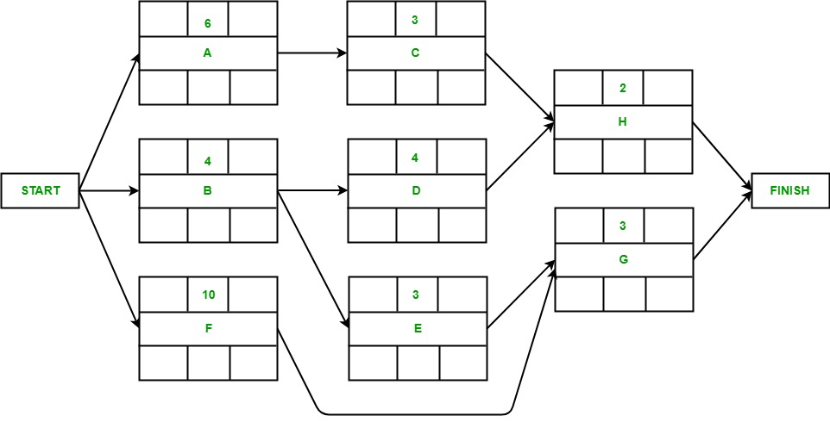

***Forward Pass:-***

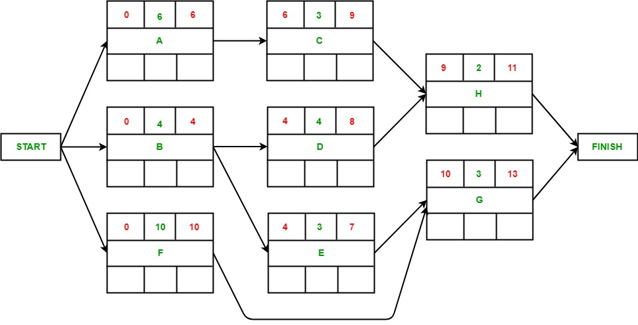

***Backward Pass:-***

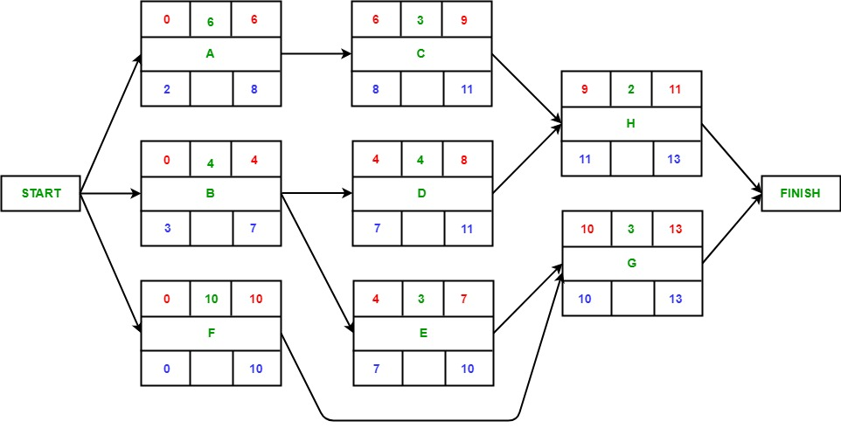

***Identifying Critical Path:-***

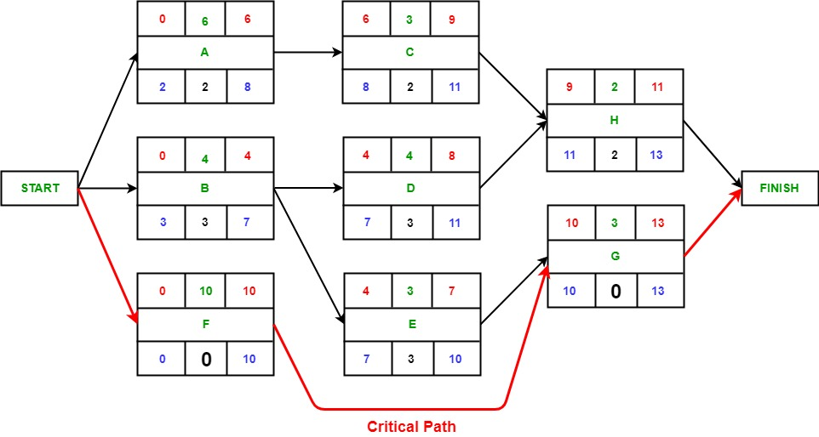

***E-R DIAGRAM FOR HOSPITAL MANAGEMENT SYSTEM***

***Registratee***

***Report***

***Health Office***

***Administration***

***Recap***

***Set Up***

***Fill In***

***Medical Record***

***Registration***

***check***kkcc

***Doctor***

***Patient***

***patient***